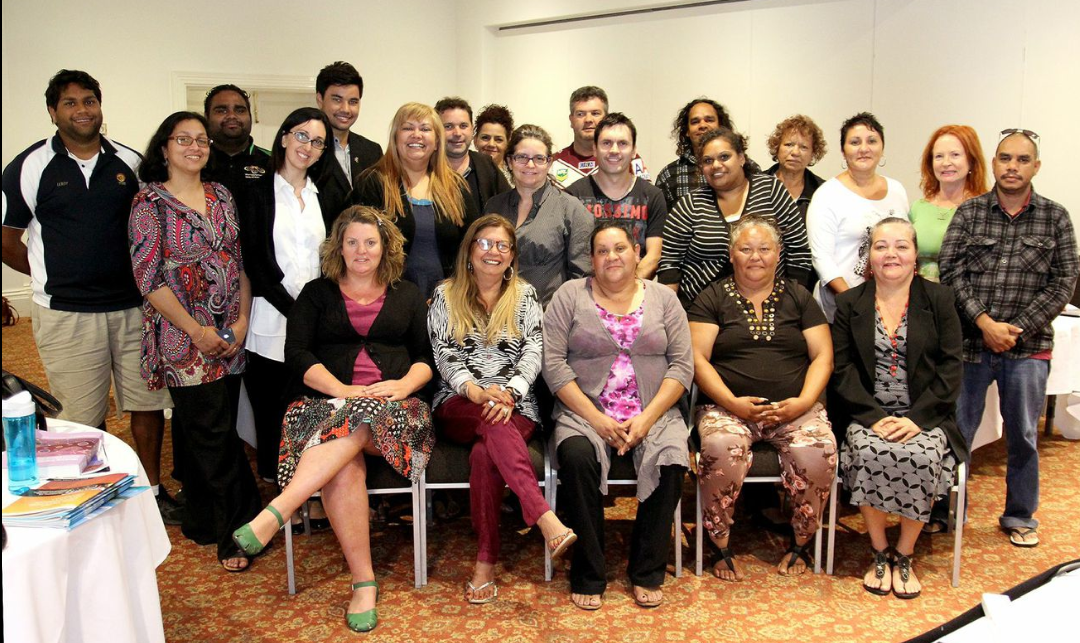
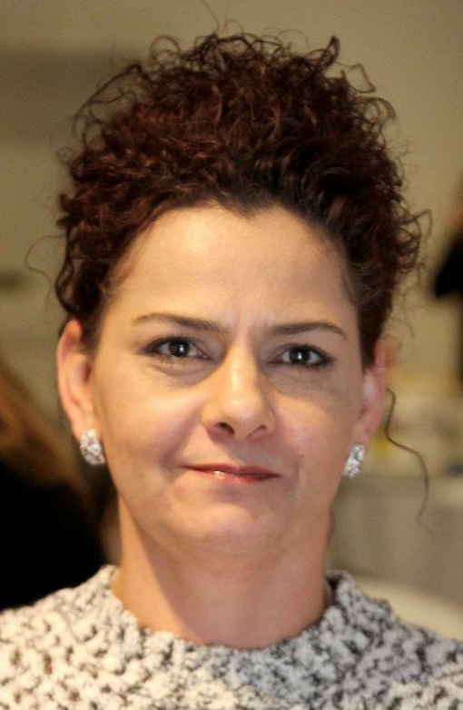
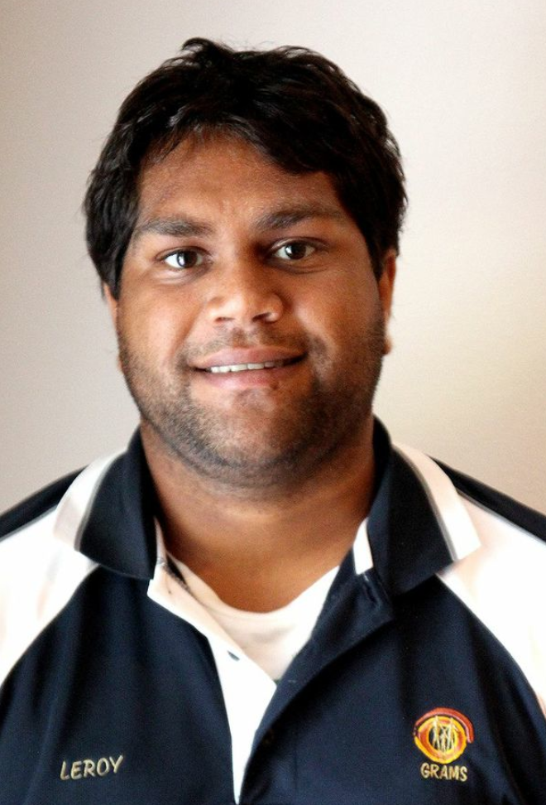
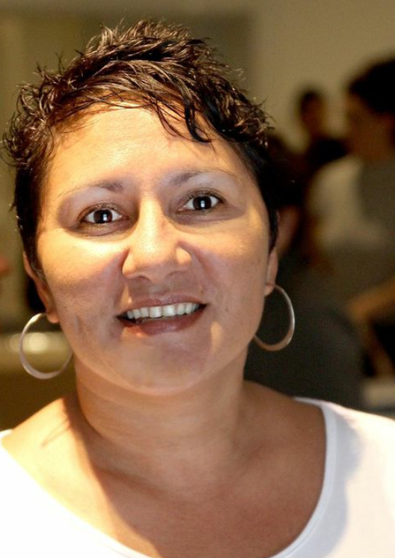
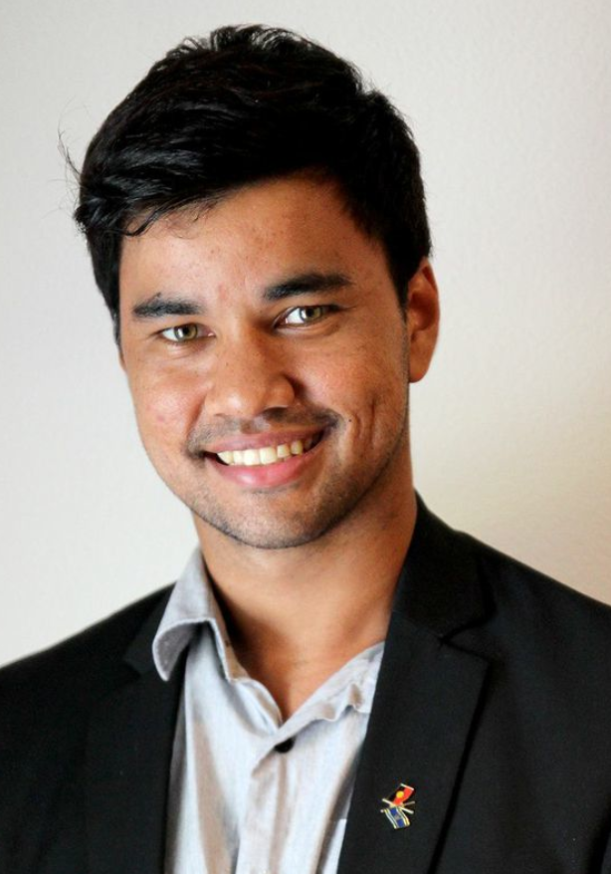
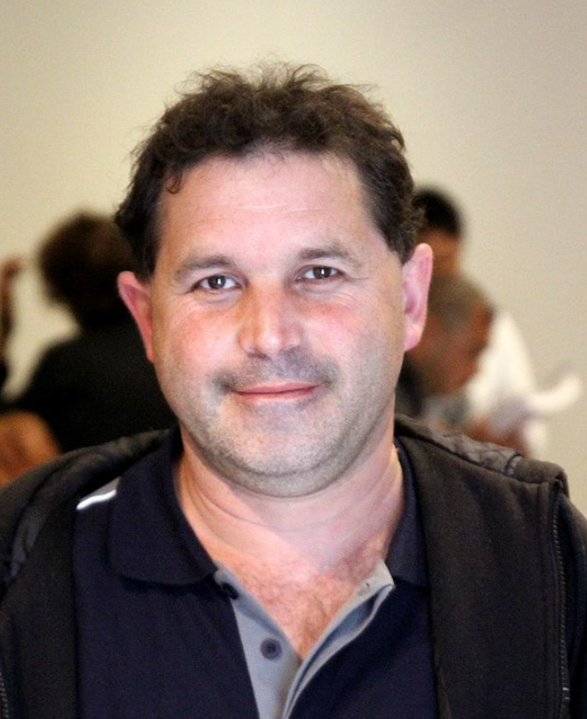
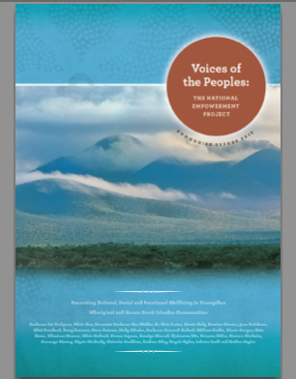
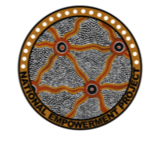
Dear NEP Researchers, Partner Organisations and interested community members,
An extended NEP team with the inclusion of the three new sites came together in November in Fremantle.
During the workshop we looked at the delivery of the Cultural, Social and Emotional Wellbeing program delivery in Kuranda and Cherbourg, with presentations from Glenis Grogan, Maria Grauner, Biri Duffin, James Stanley and Bronwyn Murray and we are thankful for their input.
NEP hopes that the CSEWB program will be extended to all sites in the future, leading to another workshop presentation regarding the Indigenous Advancement Strategy (IAS). application.

Photo: courtesy of Sam Hodgson-Bertram

Content:
- NEP Phase 3 Training Workshop

- NEP Community Report

- New Community Co-researchers

- SEWB workshop in Geraldton

- Website

- NEP Promotion

NEP Newsletter
November 2014
National Empowerment Project Update
Promoting Cultural, Social and Emotional Wellbeing
An IAS application was submitted for all NEP sites, excluding Queensland. The application is to secure funds for the delivery of the CSEWB program to all NEP sites over four years. Application progress is not expected until February 2015. In the meantime Pat will be lobbying on behalf of NEP sites endeavouring to promote the CSEWB Program and as an empowerment tool for communities.
We would like to thank all partner organisations who quickly responded to requests for support letters for the IAS application.
Pat also discussed the development of a risk management framework to ensure that both Community Co-researchers and participants are protected whilst participating in the NEP.

NEP Reports
- The Community Report has been published and sent to NEP sites for distribution to communities.
- The Report is also available on the website.

Introducing Community Co-researchers
Angela Sloan Mount Gambier
Mark Munnich Darwin

Maria Grauner Kuranda

Leroy Comeagain Geraldton
John Watson Mount Gambier

Website
We encourage you to check out the website for updates and to contribute news to the website. Please let Carolyn know any news of interest relevant to you and your community that we can post on the website.

Social and Emotional Wellbeing and Empowerment workshop - Geraldton.

Adele presented to 17 community members experiencing the devastating consequences of loss in their community. Participation was enthusiastic and engaging with very passionate expressions of empowerment. NEP thank GRAMS for assisting the with organisation of the workshop, this was very much appreciated.

Craig Quartermaine from NITV news came to the workshop and spoke to Deborah Woods, CEO Geraldton Regional Aboriginal Medical Service, following the devastating tragic recent suicides.

Please go to the link below, although it will expire to view Craig’s reporting and Deb’s interview.

http://www.sbs.com.au/ondemand/video/357167683766/NITV-News-12-November-part-1
NEP Promotion
- Pat presented NEP at the Australian Psychologist Society (APS) conference in Hobart.
- Pat and Tom Calma met with Minister Scullion in Canberra.
- Pat continues in her work as a mental health commissioner with the Mental Health Commission.
P

Please take care over the festive season, it’s a fun time for many but can also be stressful for some people, please look after self (self–care) and look after one another.
